# Position overview

## Res 5 architecture

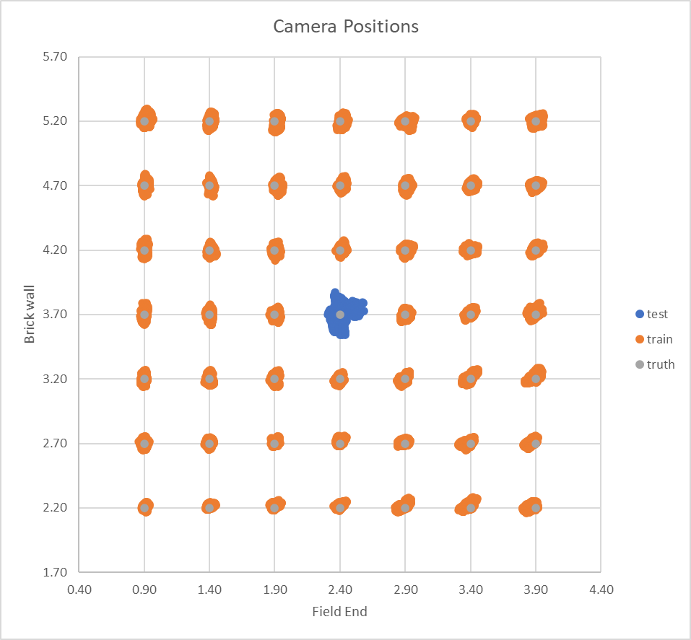

## Res 3 architecture

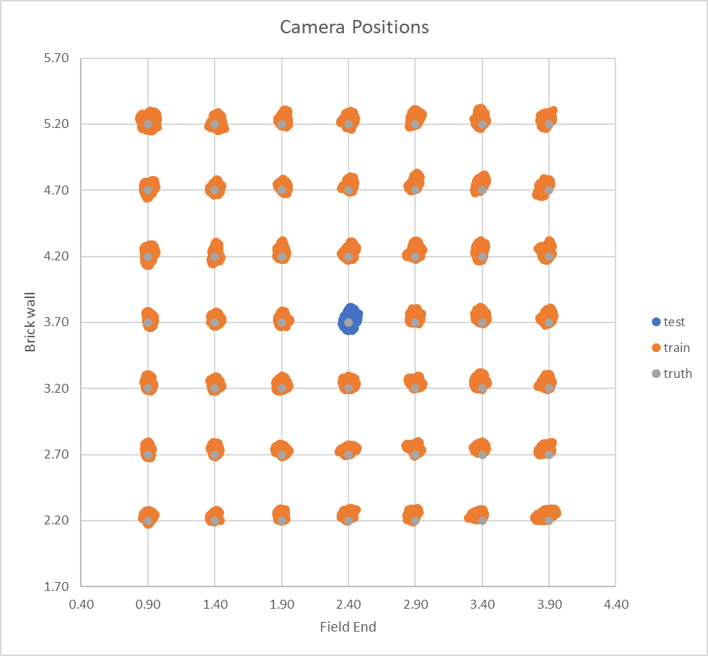

# Median Position Error training graphs

## Res 5 architecture

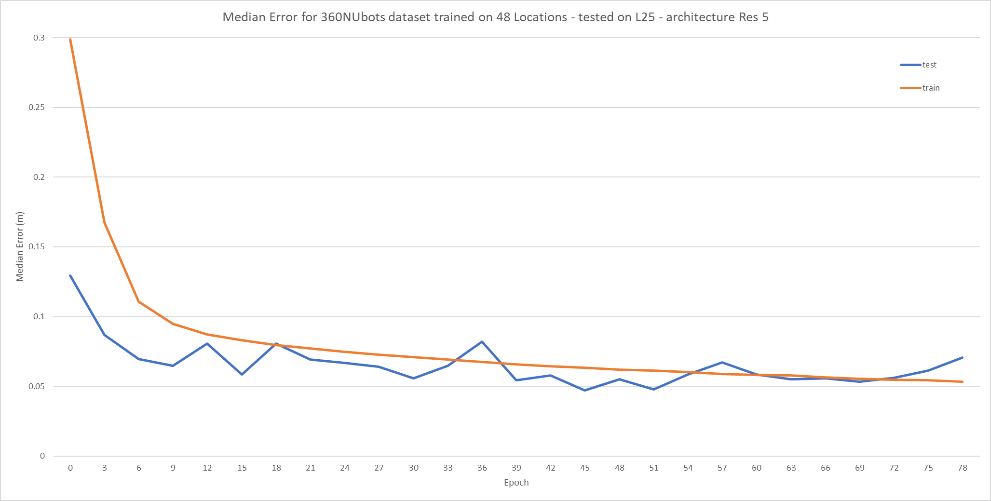

## Res 3 architecture

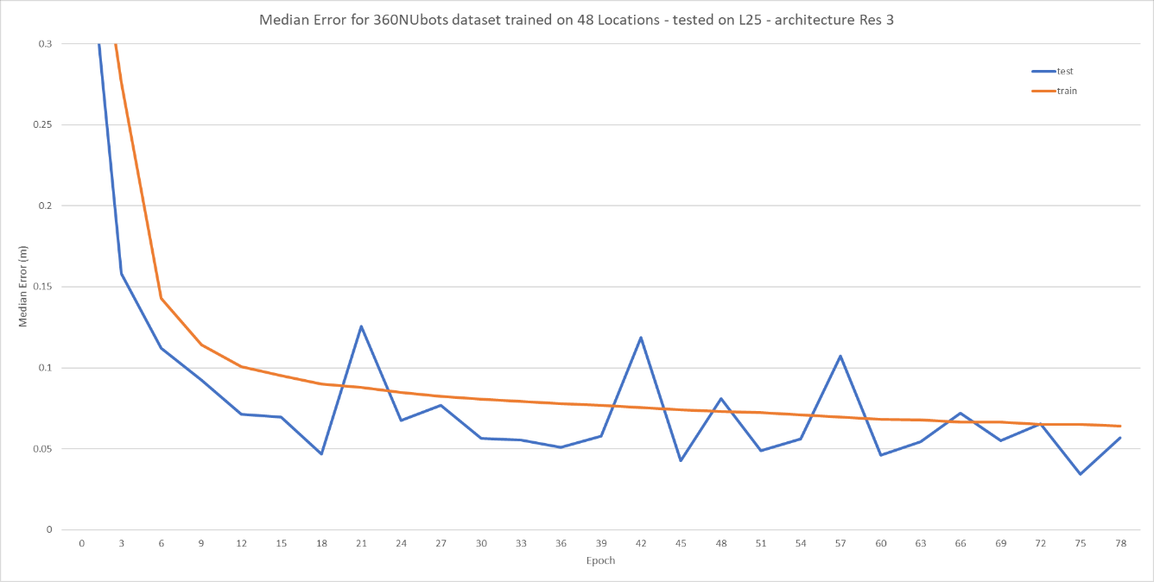

# Error spread

## Res 5 architecture

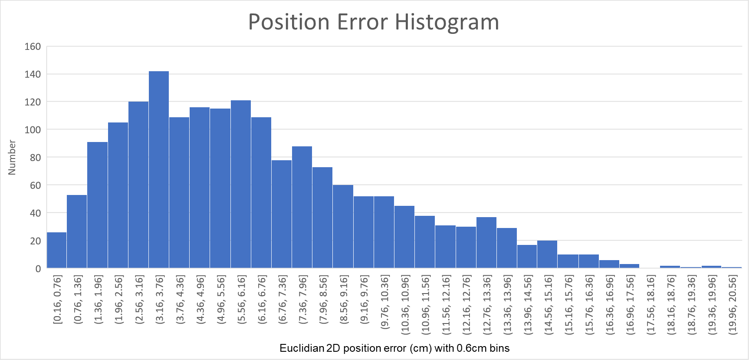

|  |  |
| --- | --- |
| Centre | Spread |
| Mean: 6.31 cm | SD: 3.74 |
| Median: 5.63 cm | IQR: 5.13 |

## Res 3 architecture

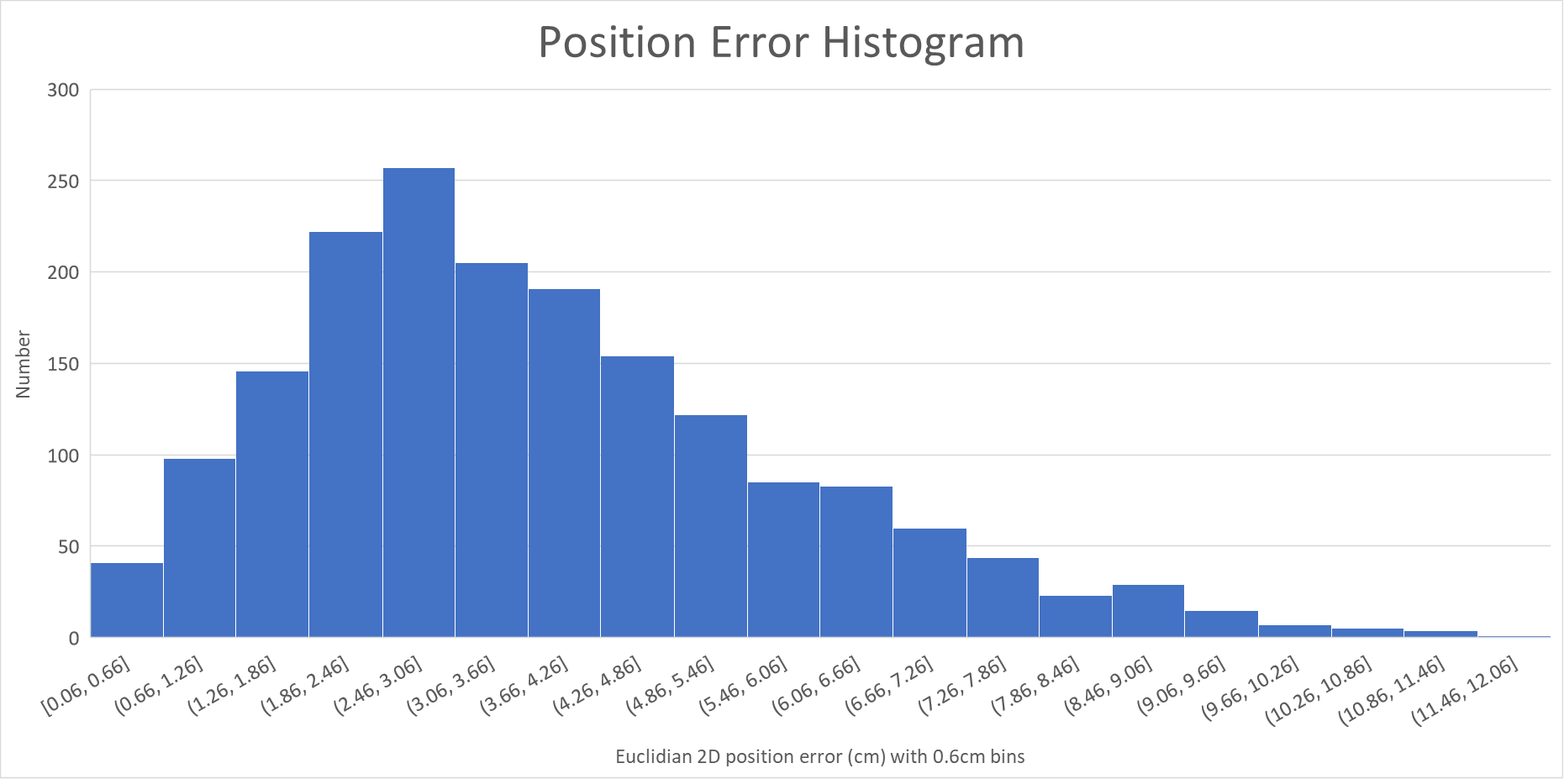

|  |  |
| --- | --- |
| Centre | Spread |
| Mean: 3.81 cm | SD: 2.07 |
| Median: 3.43 cm | IQR: 2.70 |